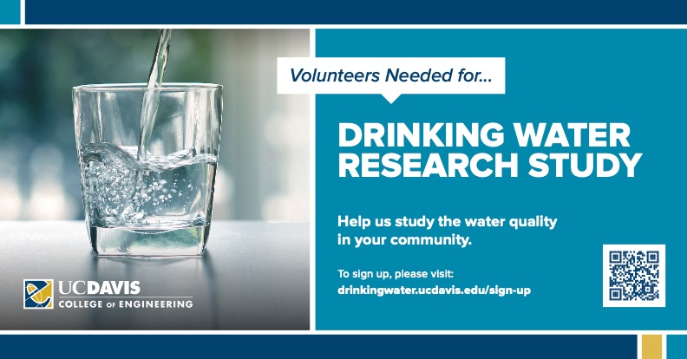

Do you call any of the following places home?

**East SF Bay Area**

*(Oakland, San Ramon, Hercules, Pinole, Richmond, Berkeley)*

**San Mateo**

**Merced**

**Madera**

**Irvine**

**West LA**

*(San Bernardino, Beverly Hills, Santa Monica, Inglewood, LA)*

**Weaverville**

We’re looking for participants in these areas to provide kitchen tap samples to help us investigate water quality statewide. Participants will be asked to provide two water samples in 2020 and will receive 2-$25 gift cards for their participation. Sampling is quick and easy with project-provided materials.

If you have friends or family in these areas, we need your help!

Please forward this along to anyone that might be interested in participating in our study.

For more information or to sign up, please visit <https://drinkingwater.ucdavis.edu/sign-up>,

or contact Dr. Gabby Black at [drinkingwater@ucdavis.edu](mailto:drinkingwater@ucdavis.edu) or (530) 754-1745.